Pumpe Falltest

<https://e.video-cdn.net/video?video-id=8mhU8tajwG18cmdUWm7TWj&player-id=CyuQddSoA2M3rBa_2FvsYD>

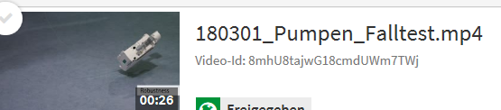

Pumpe water resistance

<https://e.video-cdn.net/video?video-id=CgNQSGfXh7PhdbGCE15FFB&player-id=CyuQddSoA2M3rBa_2FvsYD>

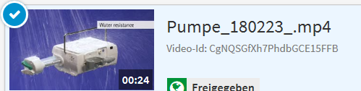

04 Rate calculation

<https://e.video-cdn.net/video?video-id=6wzPvSWLLTWMn7GBM9UamW&player-id=CyuQddSoA2M3rBa_2FvsYD>

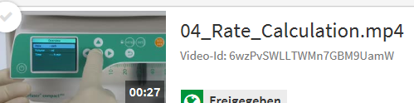

06 Pressure level

<https://e.video-cdn.net/video?video-id=DqrQXTLeLqzyXxmWYoQQm3&player-id=CyuQddSoA2M3rBa_2FvsYD>

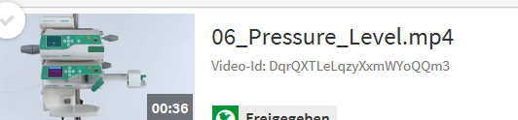

10 turn off

<https://e.video-cdn.net/video?video-id=6AtjgnK1jmioRAR7BiwGbF&player-id=CyuQddSoA2M3rBa_2FvsYD>

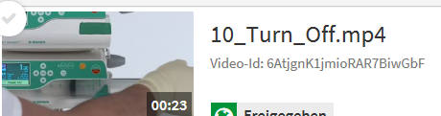

05 Bolus

<https://e.video-cdn.net/video?video-id=Eee8VfhFxXfQNoM7X7HDab&player-id=CyuQddSoA2M3rBa_2FvsYD>

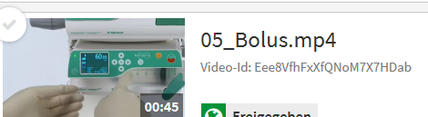

11 Infusomat

<https://e.video-cdn.net/video?video-id=4oPB26oZsSLr7edMuiCZnj&player-id=CyuQddSoA2M3rBa_2FvsYD>

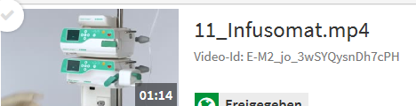

08 Standby

<https://e.video-cdn.net/video?video-id=C7SzKZtszgxMG6jBJE45Eb&player-id=CyuQddSoA2M3rBa_2FvsYD>

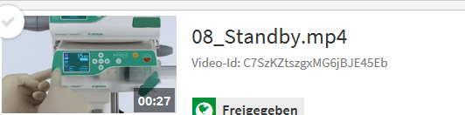

09 Drug Library

<https://e.video-cdn.net/video?video-id=3KU_Hj2Torsq6Qwrze-aNK&player-id=CyuQddSoA2M3rBa_2FvsYD>

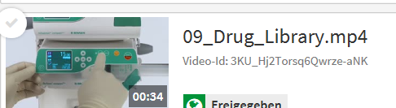

03 Reset Therapy

<https://e.video-cdn.net/video?video-id=DKBnKLC-Xk3j_kqFCrwoR8&player-id=CyuQddSoA2M3rBa_2FvsYD>

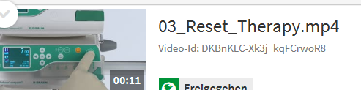

01 Start up Perfusor

<https://e.video-cdn.net/video?video-id=2dY-HtQsVzXKd7UGVG2Wg3&player-id=CyuQddSoA2M3rBa_2FvsYD>

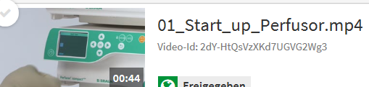

02 Rate change

<https://e.video-cdn.net/video?video-id=8SquR29Ye4bgny2PMEgzyX&player-id=CyuQddSoA2M3rBa_2FvsYD>

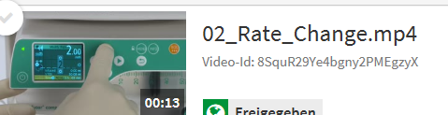

07 Dose rate calculation

<https://e.video-cdn.net/video?video-id=1o36S1iKZoYTcC8p8z3JJQ&player-id=CyuQddSoA2M3rBa_2FvsYD>

